Ontology Creation

# Question 2

(b)

No problems creating the ontology.

(c)

## Part 1

### Query 1

Pizza that (hasTopping some CheeseTopping) and (hasTopping some MeatTopping)

#### Result 1

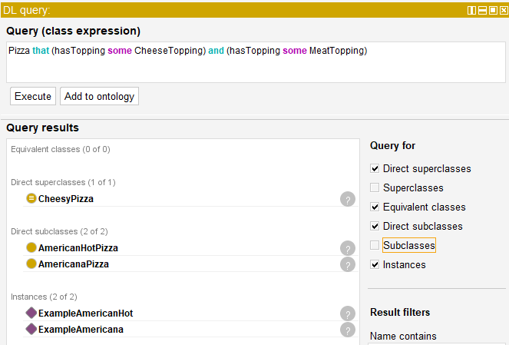

### 

### Query 2

Pizza that (hasTopping some HamTopping) or (hasTopping some PepperoniTopping) or (hasTopping some SalamiTopping) or (hasTopping some SpicyBeefTopping)

#### Result 2

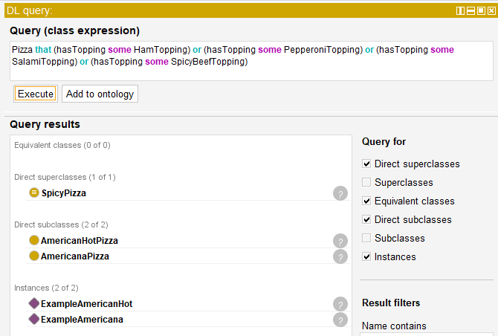

### Query 3

Pizza that (hasTopping some JalapenoPepperTopping) and (hasTopping some TomatoTopping)

#### Result 3

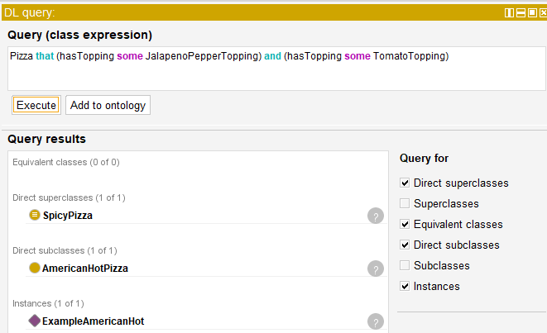

### 

### Query 4

Pizza that (hasTopping exactly 3)

#### Result 4

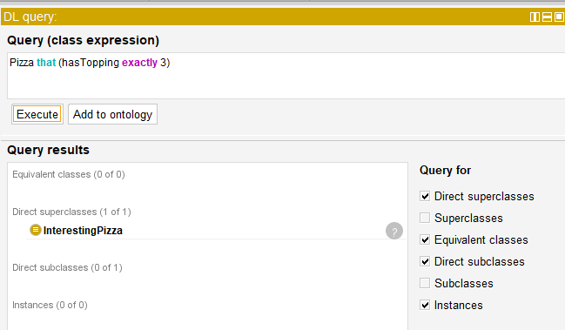

## Part 2

Logical expression: hasBase exactly 1 PizzaBase

Answer: It is acceptable that we create a pizza with no base because the query only expresses that if the pizza has a base, it can only be one. But if it has none it doesn’t concern the query.

## Part 3

Defining expression: Pizza and (hasTopping only (MozarellaTopping or TomatoTopping))

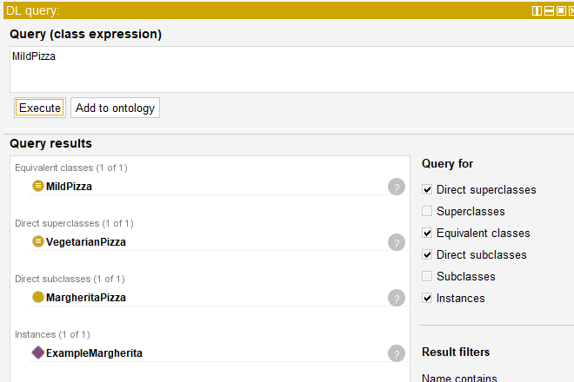

(d)

### Query 1

PREFIX rdf: <http://www.w3.org/1999/02/22-rdf-syntax-ns#>

PREFIX owl: <http://www.w3.org/2002/07/owl#>

PREFIX rdfs: <http://www.w3.org/2000/01/rdf-schema#>

PREFIX xsd: <http://www.w3.org/2001/XMLSchema#>

PREFIX pizza: <http://www.pizza.com/ontologies/pizza.owl#>

SELECT * WHERE {

?topping rdfs:subClassOf pizza:PizzaTopping .

}

#### Result 1

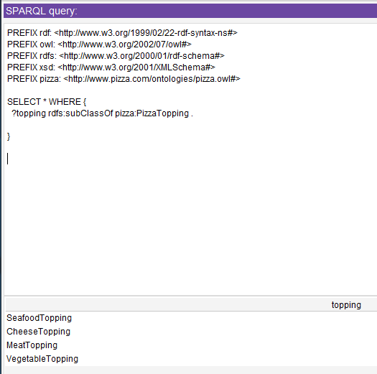

### 

### Query 2

PREFIX rdf: <http://www.w3.org/1999/02/22-rdf-syntax-ns#>

PREFIX owl: <http://www.w3.org/2002/07/owl#>

PREFIX rdfs: <http://www.w3.org/2000/01/rdf-schema#>

PREFIX xsd: <http://www.w3.org/2001/XMLSchema#>

PREFIX pizza: <http://www.pizza.com/ontologies/pizza.owl#>

SELECT distinct ?s WHERE {

?s rdfs:subClassOf ?restriction .

?restriction owl:onProperty pizza:hasSpiciness .

?restriction owl:someValuesFrom pizza:Hot .

}

#### Result 2

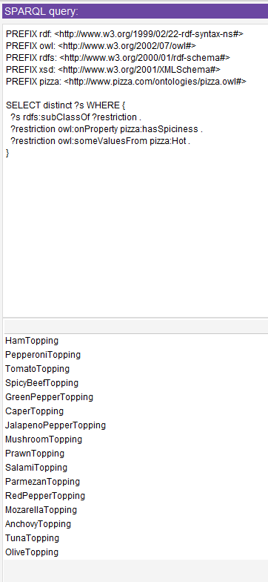

# 

# Question 3

(i)

I wasn’t able to upload to a website because I don’t have a website neither time to create it.

So I’m sending the file instead of the URL.

(ii)

## DL

### Query 1

member some Organization

#### Result 1

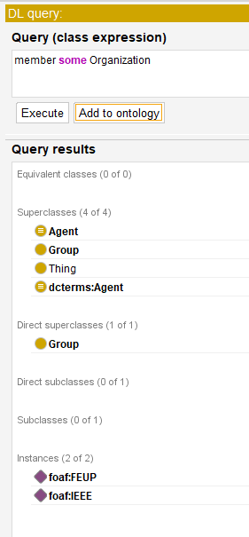

### Query 2

schoolHomepage some Person

#### Result 2

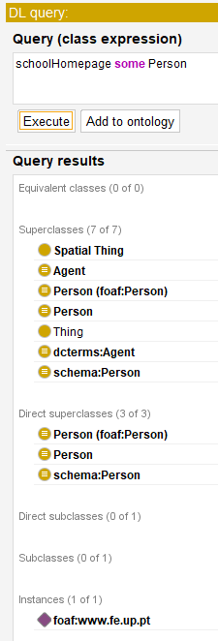

## 

## SPARQL

### Query 1

PREFIX rdf: <http://www.w3.org/1999/02/22-rdf-syntax-ns#>

PREFIX owl: <http://www.w3.org/2002/07/owl#>

PREFIX rdfs: <http://www.w3.org/2000/01/rdf-schema#>

PREFIX xsd: <http://www.w3.org/2001/XMLSchema#>

PREFIX foaf: <http://xmlns.com/foaf/0.1/>

SELECT ?subject WHERE {

?subject rdfs:subClassOf foaf:Agent

}

#### Result 1

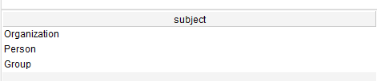

### Query 2

PREFIX rdf: <http://www.w3.org/1999/02/22-rdf-syntax-ns#>

PREFIX owl: <http://www.w3.org/2002/07/owl#>

PREFIX rdfs: <http://www.w3.org/2000/01/rdf-schema#>

PREFIX xsd: <http://www.w3.org/2001/XMLSchema#>

PREFIX foaf: <http://xmlns.com/foaf/0.1/>

SELECT ?subject WHERE {

?subject rdfs:subClassOf foaf:Document

}

#### Result 2

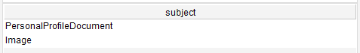

Queries that the result was an empty table, although I think it should work just fine:

PREFIX rdf: <http://www.w3.org/1999/02/22-rdf-syntax-ns#>

PREFIX owl: <http://www.w3.org/2002/07/owl#>

PREFIX rdfs: <http://www.w3.org/2000/01/rdf-schema#>

PREFIX xsd: <http://www.w3.org/2001/XMLSchema#>

PREFIX foaf: <http://xmlns.com/foaf/0.1/>

SELECT ?name WHERE {

?x foaf:name ?name

}

In this query the result should be a table with one line containing my name: ‘Ines_Soares’

PREFIX rdf: <http://www.w3.org/1999/02/22-rdf-syntax-ns#>

PREFIX owl: <http://www.w3.org/2002/07/owl#>

PREFIX rdfs: <http://www.w3.org/2000/01/rdf-schema#>

PREFIX xsd: <http://www.w3.org/2001/XMLSchema#>

PREFIX foaf: <http://xmlns.com/foaf/0.1/>

SELECT ?mbox WHERE {

?x foaf:name "Ines_Soares" .

?x foaf:personal_mailbox ?mbox

}

In this query the result should be a table with one line containing the email that I put in my profile: ‘[inesoares.6-rp@hotmail.com](mailto:inesoares.6-rp@hotmail.com)’

PREFIX rdf: <http://www.w3.org/1999/02/22-rdf-syntax-ns#>

PREFIX owl: <http://www.w3.org/2002/07/owl#>

PREFIX rdfs: <http://www.w3.org/2000/01/rdf-schema#>

PREFIX xsd: <http://www.w3.org/2001/XMLSchema#>

PREFIX foaf: <http://xmlns.com/foaf/0.1/>

SELECT ?nick ?name WHERE {

?x rdf:type foaf:Person .

?x foaf:nick ?nick .

?x foaf:name ?name

}

In this query the result should be a table with one line and two columns containing the nickname and the name that I put in my profile: ‘nocas’ and ‘Ines_Soares’

# 

# Question 4

DBPedia Ontology

“The DBpedia Ontology is a shallow, cross-domain ontology, which has been manually created based on the most commonly used infoboxes within Wikipedia. The ontology currently covers 685 classes which form a subsumption hierarchy and are described by 2,795 different properties.”

<https://wiki.dbpedia.org/services-resources/ontology>

SPARQL endpoint: <http://dbpedia.org/sparql>

## SPARQL Queries

### Query 1

PREFIX rdf: <http://www.w3.org/1999/02/22-rdf-syntax-ns#>

PREFIX owl: <http://www.w3.org/2002/07/owl#>

PREFIX rdfs: <http://www.w3.org/2000/01/rdf-schema#>

PREFIX xsd: <http://www.w3.org/2001/XMLSchema#>

PREFIX dbp: <http://dbpedia.org/ontology/>

SELECT ?subject WHERE {

?subject rdfs:subClassOf dbp:Place

}

#### Result 1

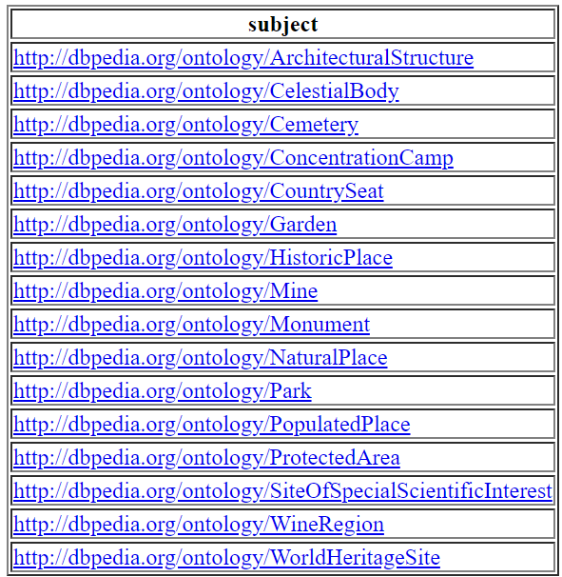

The result represents all the subclasses of the class Place: ArchitecturalStructure, CelestialBody, Cemetery, ConcentrationCamp, CountrySeat, Garden, HistoricPlace...

### Query 2

PREFIX rdf: <http://www.w3.org/1999/02/22-rdf-syntax-ns#>

PREFIX owl: <http://www.w3.org/2002/07/owl#>

PREFIX rdfs: <http://www.w3.org/2000/01/rdf-schema#>

PREFIX xsd: <http://www.w3.org/2001/XMLSchema#>

PREFIX dbp: <http://dbpedia.org/ontology/>

SELECT ?subject WHERE {

?subject rdfs:subClassOf dbp:Person

}

#### Result 2

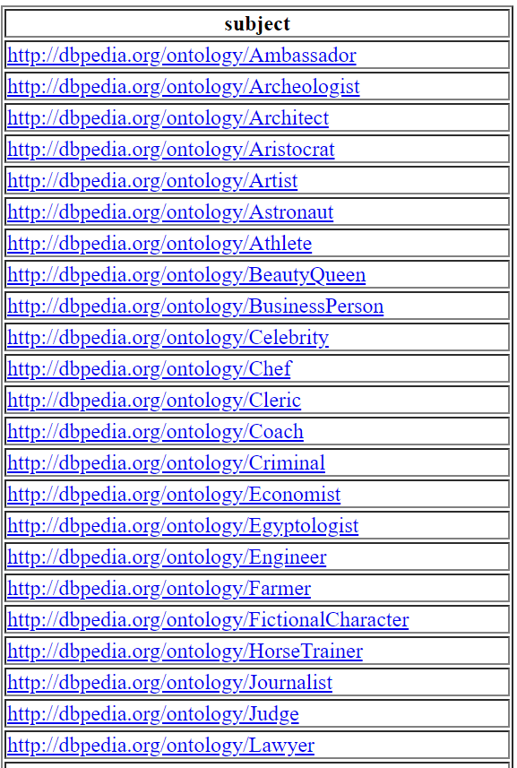

The result represents not all but the first subclasses of the class Person (because there were too many and they didn’t fit): Ambassador, Archeologist, Architect, Aristocrat...

Queries that the result is an empty table, although I think it should work just fine:

##### Query 1

PREFIX rdfs: <http://www.w3.org/2000/01/rdf-schema#>

PREFIX type: <http://dbpedia.org/class/yago/>

PREFIX prop: <http://dbpedia.org/property/>

SELECT ?country_name ?population

WHERE {

?country a type:LandlockedCountries ;

rdfs:label ?country_name ;

prop:populationEstimate ?population .

FILTER (?population > 15000000) .

}

###### Expected result:

In this query the result should be a table with many lines and two columns containing the country_name and the population of the country

##### Query 2

PREFIX type: <http://dbpedia.org/class/yago/>

PREFIX prop: <http://dbpedia.org/property/>

SELECT ?country_name ?population

WHERE {

?country a type:LandlockedCountries ;

rdfs:label ?country_name ;

prop:populationEstimate ?population .

FILTER (?population > 15000000 && langMatches(lang(?country_name), "EN")) .

} ORDER BY DESC(?population)

###### Expected result:

In this query the result should be a table with fewer lines than the previous query (because we are filtering the population which is greater than 15 million) and two columns containing the country_name and the population of the country, order by the highest to the lowest

## Ontology made by me

### DL Queries

#### Query 1

PortugueseFood or ItalianFood that hasCalories value "High"

##### Result 1

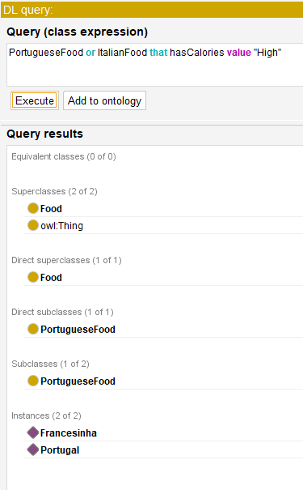

#### 

#### Query 2

Sports that (hasPlayers value 6 or hasPlayers value 11)

##### Result 2

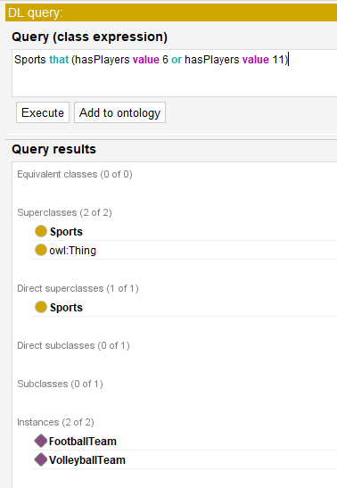

### 

### SPARQL Queries

#### Query

PREFIX rdf: <http://www.w3.org/1999/02/22-rdf-syntax-ns#>

PREFIX owl: <http://www.w3.org/2002/07/owl#>

PREFIX rdfs: <http://www.w3.org/2000/01/rdf-schema#>

PREFIX xsd: <http://www.w3.org/2001/XMLSchema#>

SELECT ?subject ?object

WHERE { ?subject rdfs:subClassOf ?object }

##### Result

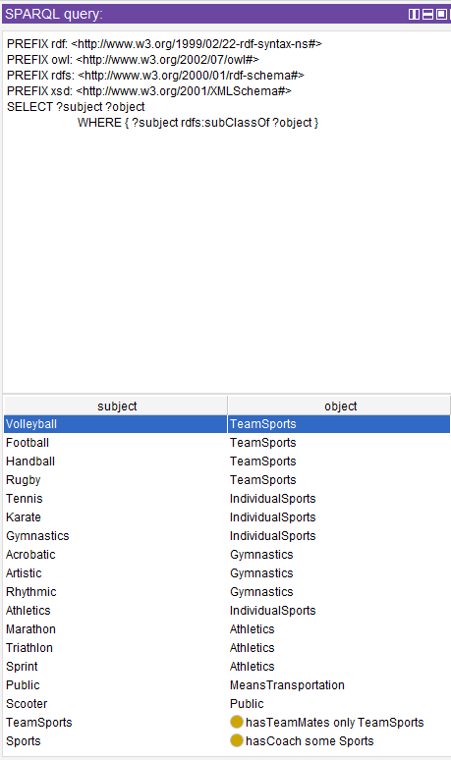

This picture only shows one part of the solution because the list was too big and didn’t fit.